Relationship Between Tech Use and Mental Wellbeing
Course: COMP-3250
Professor: Dr. Andreas S. Maniatis
Team Members: Kerui Li, Rafael Cabangon, Mona Hicham Moussa, Howaida Nazari

Contents
Abstract 2
Project Scope and Problem Description 3
Team Involvement and Project Organization 3
Project Design and Development 4
Data Preparation 4
Descriptive Analytics (Phase 3 and 4) 4
Predictive Analysis (Phase 3 and 4) 6
Findings and Future Work 7
Key Discoveries from Visual Analytics 7
Predictive Insights from Machine Learning 7
Actionable Insights 8
Future Work 8
References 8
Addendums 9

Abstract
The ongoing debate about technology and mental health often focuses on the negative effects of screen time. This project examines the specific relationship between daily technology habits, including social media use and work hours, and mental well-being indicators like stress and sleep quality. We used the Tech Use and Stress Wellness dataset from Kaggle to analyze these patterns. Our team applied a dual approach. First, we used Power BI to create visual analytics that map out the data. Second, we built a Random Forest machine learning model in Python to predict stress levels based on user behavior. The analysis shows that time spent on social media and work-related screen time are the main drivers of high stress. However, the data also highlights those healthy offline habits act as a strong buffer. Regular physical activity and daily mindfulness practice of 25 minutes or more significantly improve mood and sleep quality, even for users with high screen time. The project concludes that the negative impacts of technology can be actively managed and reduced through specific wellness habits.

Project Scope and Problem Description
Technology usage is a central pillar of modern life. It dictates how people work, learn, and relax. While digital devices provide incredible efficiency and connectivity, they also introduce a significant public health challenge. There is growing concern that excessive screen time correlates directly with declining mental well-being, specifically leading to disrupted sleep patterns, higher depression scores, and increased daily stress.
The core problem is a lack of precise, data-backed understanding of how different types of technology usage impact specific mental health indicators. General advice often tells individuals to simply reduce their screen time. This is usually an unrealistic goal for students and working professionals. The public needs to identify the specific usage patterns that pose the greatest risk, such as prolonged social media scrolling versus work-related screen time. More importantly, we must determine if healthy offline habits can buffer these negative effects.
The scope of this project is to analyze the Tech Use and Stress Wellness dataset to map the direct relationships between lifestyle behaviors and mental health. Our primary hypothesis is that high daily screen time, particularly on social media, correlates with increased stress and depression scores. However, we hypothesize that healthy offline habits, such as regular physical activity and daily mindfulness practice, act as strong mitigating factors that improve mood and sleep quality even when screen time remains high.
By testing this hypothesis with descriptive analytics in Power BI and a predictive Random Forest machine learning model in Python, this project provides actionable value for the real world. Understanding these nuances allows corporate wellness programs, healthcare providers, and digital health applications to design better interventions. Instead of setting unrealistic screen time limits, stakeholders can promote targeted offline activities to help individuals balance digital connectivity with long-term mental well-being.

Team Involvement and Project Organization
The team utilized an Agile project management framework to ensure equitable distribution of work and strict adherence to the project deadlines. Work was organized into weekly sprints focusing on distinct phases of the Data Analytics Lifecycle, from initial data discovery to model building. Hive was utilized as the primary project management tool to assign tasks, track sprint progress, and manage the submission pipeline for the final deliverables.
To execute the hybrid descriptive and predictive analytics methodology effectively, team members assumed specific technical and operational roles:
- John (Rafael) Cabangon (Lead Data Analyst): Managed the descriptive analytics phase. Responsible for data ingestion, cleaning, and building the interactive visual analytics dashboard using Power BI. Authored the project scope and problem description for the final report.
- Howaida Nazari (Machine Learning Engineer): Managed the predictive analytics phase. Responsible for developing, testing, and optimizing the Python based Random Forest classifier. Authored the methodology and solution statement documentation.
- Kerui Li (Scrum Master and Documentation Lead): Facilitated weekly team stand up meetings and managed the Hive task board. Responsible for drafting the abstract, compiling the extended documentation appendices, and ensuring formatting compliance across all deliverables.
- Mona Hicham Moussa (Business Analyst): Focused on translating the data findings into actionable insights. Responsible for articulating the project motivation, defining the business value of the analytics, and structuring the final digital presentation.
This structured approach ensured that the descriptive visualizations and the predictive machine learning models were developed in parallel and seamlessly integrated into the final application.

Project Design and Development
The project was executed following the Data Analytics Lifecycle (DAL) phases discussed in class. The workload was split between data preparation, descriptive visual analytics using Power BI, and predictive modeling using Python.

Data Preparation
The raw dataset was imported into Power BI using the Power Query editor. The team performed Extract, Transform, and Load (ETL) processes to prepare the data for analysis. This involved cleaning missing values, standardizing data types, and ensuring critical columns such as daily_screen_time_hours, physical_activity_hours_per_week, mental_health_score, and weekly_depression_score were formatted correctly as numerical values.

Descriptive Analytics (Phase 3 and 4)
Power BI was utilized to explore the data and build visual models that address our core problem description. We focused on three primary analyses to test our hypothesis regarding technology use and offline habits.
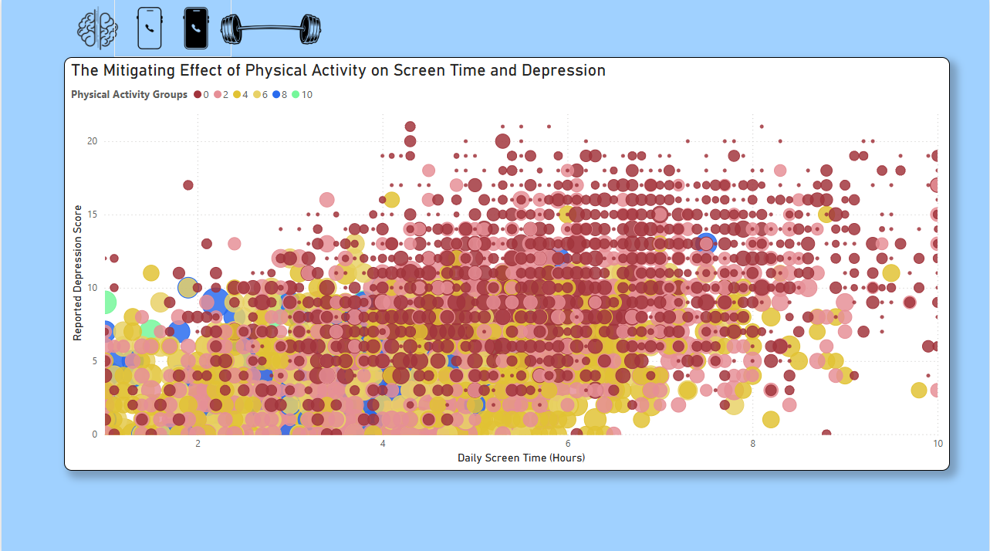
First, we investigated whether healthy offline habits, such as physical activity, mitigate the negative mental health impacts of high daily screen time. We mapped the daily_screen_time_hours against the weekly_depression_score and mental_health_score, using physical_activity_hours_per_week as a key grouping variable. The visualization demonstrates that users maintaining regular physical activity report better mental health scores, acting as a buffer against the negative effects of prolonged screen exposure.

Next, we analyzed if there is reason to believe that having higher daily screen time usage will likely result in lower sleep quality, and we examined the relationship between peoples mood and the quality of sleep they are experiencing. By visualizing daily_screen_time_hours, sleep_quality, and mood_rating together, the data reveals a clear pattern. High screen time is associated with lower sleep metrics, and there is a direct positive relationship showing that individuals with higher sleep quality consistently report better mood ratings.
Insert Mona’s Visualization
Finally, this analysis aims to examine how physical activity influences sleep quality. The chart shows that as the number of physical activity hours per week increases, sleep quality generally improves. Individuals with middle levels of physical activity tend to have higher sleep quality compared to those with low activity levels. However, at very high levels of physical activity, there is a slight decrease in sleep quality, which may be due to a smaller number of observations in that range. Overall, the results suggest that engaging in regular physical activity is associated with better sleep quality.
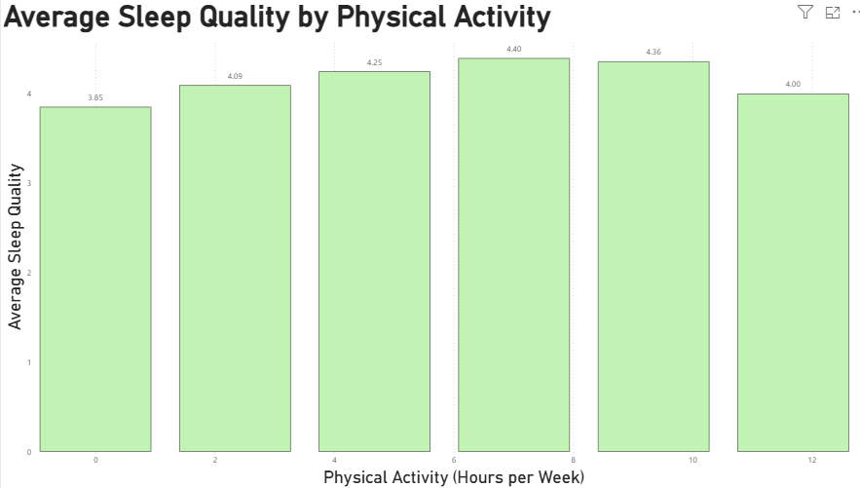

Predictive Analysis (Phase 3 and 4)
To complement the descriptive visualizations, we developed a Machine Learning approach using Python. The goal was to build a predictive model capable of forecasting a user's stress level based on their lifestyle variables.
Before training our Random Forest classifier, we generated a correlation matrix to understand the strength of the relationships between all features and the target variable. The matrix clearly illustrates which behaviors are the primary catalysts for negative mental health. Time spent on social media and time spent working show the strongest positive correlations with stress levels, scoring 0.95 and 0.83 respectively.
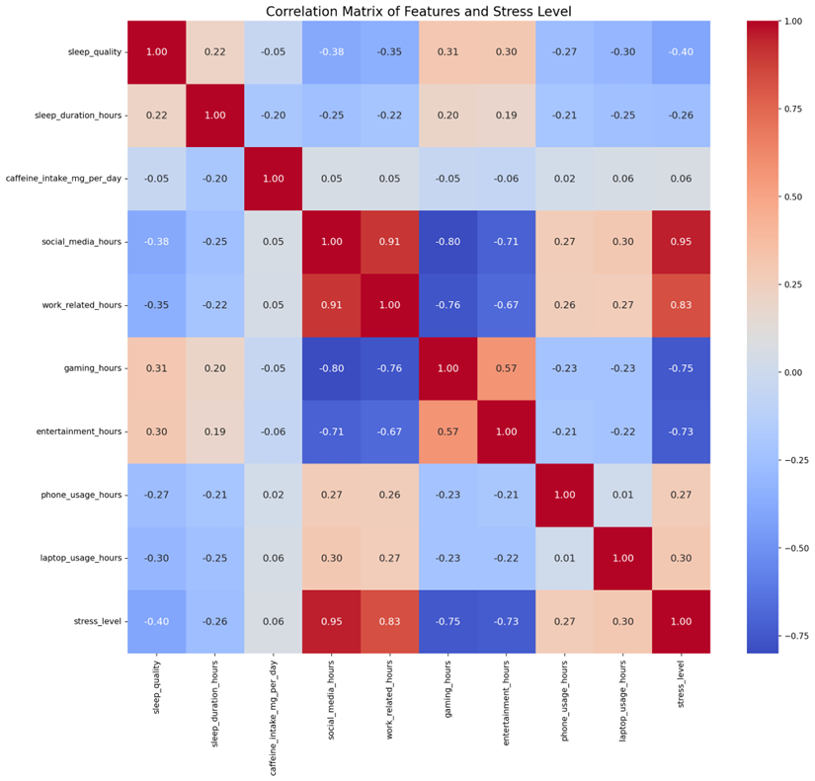

Findings and Future Work

Key Discoveries from Visual Analytics
The visual exploration in Power BI confirmed our initial hypothesis regarding the relationship between technology habits and mental health. The data shows a direct positive correlation between the number of hours spent on social media per day and the average depression score. Individuals who spend more time on social media consistently report higher levels of depression.
Conversely, engaging in regular physical activity is associated with better sleep quality and acts as a mitigating factor. Individuals maintaining middle levels of physical activity report higher sleep quality than those with low activity levels. There is a slight decrease in sleep quality for those at very high activity levels, though this is likely due to a smaller number of observations in that specific range. Furthermore, the analysis proves that high daily screen time results in lower sleep quality, while individuals experiencing higher sleep quality consistently report higher mood ratings.

Predictive Insights from Machine Learning
The Random Forest classifier provided quantifiable evidence of the specific behaviors driving stress. The correlation matrix revealed that time spent on social media and time spent working exhibit very strong positive correlations with stress levels, scoring 0.95 and 0.83 respectively. A severe multicollinearity score of 0.91 was found between social media use and work duration. This indicates that high intensity workloads often trigger surging social media usage.
Protective factors were also identified. Sleep duration (-0.14) and sleep quality (-0.12) exhibit negative correlations with stress. Gaming duration (-0.75) and leisure time (-0.73) also showed significant negative correlations, suggesting these specific screen activities function as stress relief rather than catalysts for poor mental health.
Finally, the model highlighted a disparity between psychological and physiological recovery when using wellness applications. Mood ratings showed a strong positive linear correlation with the duration of mindfulness practice. However, sleep quality did not show a steady linear improvement. A threshold effect exists where daily mindfulness practice must exceed 25 minutes to produce a measurable, one point improvement in sleep quality.

Actionable Insights
These findings provide concrete value for stakeholders designing wellness interventions. Instead of focusing on broad reductions in total screen time, health applications and corporate wellness programs should target specific behaviors. Interventions should prioritize breaking the cycle of high workloads triggering social media usage. Programs should also encourage middle levels of physical activity and ensure mindfulness exercises meet the 25 minute daily threshold for maximum effectiveness in improving sleep.

Future Work
Future development of this analytics application should integrate real time data from wearable fitness devices. Incorporating live metrics such as heart rate variability and precise sleep cycle tracking would allow the machine learning model to move from static predictions to dynamic stress monitoring. Expanding the dataset to include a wider range of occupations and geographic regions would also improve the accuracy and global application of the predictive models.

References
Hive. Hive Project Management Software. Hive, 2024, hive.com.
Microsoft. Power BI Desktop. Microsoft, 2024, powerbi.microsoft.com.
Nagpal, Prabhavalkar. Tech Use and Stress Wellness Dataset. Kaggle, 2024, www.kaggle.com/datasets/nagpalprabhavalkar/tech-use-and-stress-wellness.
Pedregosa, Fabian, et al. "Scikit-learn: Machine Learning in Python." Journal of Machine Learning Research, vol. 12, 2011, pp. 2825-2830, jmlr.csail.mit.edu/papers/v12/pedregosa11a.html.
Python Software Foundation. Python Language Reference. Python Software Foundation, 2024, www.python.org.

Addendums

Tech Use and Mental Wellbeing

Project Overview and User Guide

1. Project Overview
This project investigates the Relationship Between Tech Use and Mental Wellbeing through a dual-lens approach:
• A technical analytical framework built in Python
• An interactive visualization layer developed in Power BI
The system aims to bridge the gap between complex statistical modeling and intuitive data storytelling. While the Python component handles the rigorous data orchestration including preprocessing, exploratory data analysis (EDA), and predictive modeling the Power BI dashboard translates these findings into a dynamic, user-facing interface. This complementary structure ensures that both technical stakeholders and general users can derive meaningful insights into how digital habits correlate with psychological health indicators.

2. User Guide: Python Analytical Component
The analytical backbone of this project is contained within a Jupyter Notebook (.ipynb). This format facilitates a literate programming approach, where code execution is interspersed with explanatory documentation to ensure the reproducibility of our findings.
2.1 Environment and Execution
To interact with the analysis, users should open the notebook file using Visual Studio Code (with the Jupyter extension) or a standard Jupyter lab environment. The workflow is partitioned into sequential cells:
1. Initialization:
Execute the top-level cells to import necessary dependencies and load the dataset into the environment.
2. Data Governance:
The notebook automatically performs data cleaning and feature engineering. This includes handling null values and normalizing tech-use metrics to ensure model stability.
3. Heuristic Analysis:
Through matplotlib and seaborn integrations, the notebook generates high-fidelity plots. Users can observe data distributions and preliminary correlations here.
2.2 Machine Learning Integration
Beyond static analysis, the notebook implements a machine learning pipeline. This section trains a model on selected behavioral features to predict wellbeing outcomes.
Evaluation:
Users can review performance metrics (e.g., Accuracy, F1-score) directly within the output cells.
Flexibility:
While designed as a 'run-through' script, advanced users may modify hyper-parameters or input features to observe how the predictive boundaries shift.

3. User Guide: Power BI Dashboard
The Power BI component (.pbix) serves as the interactive storytelling hub of the project. It is designed for stakeholders who require immediate, visual access to the data trends without engaging with the underlying source code.
3.1 Accessing the Dashboard
Users need Power BI Desktop installed to view the project. Upon opening the file:
Data Connectivity:
The dashboard is pre-configured with the cleaned dataset. No manual data mapping or SQL querying is required from the user's end.
Layout:
The interface is divided into thematic sections such as demographic breakdowns and correlation matrices allowing for a structured exploration of the mental health landscape.
3.2 Interactive Exploration
The strength of this dashboard lies in its interactivity. Users are encouraged to:
Cross-Filtering:
Click on specific data points (e.g., a specific age group or high-screen-time bracket) to see how the rest of the report dynamically updates to reflect that subset.
Insight Discovery:
Use the built-in slicers to isolate specific variables. This allows for a granular comparison between different technology usage patterns and their corresponding wellbeing scores, making complex multidimensional data easy to interpret.

4. Conclusion
By integrating the technical depth of Python with the accessibility of Power BI, this project provides a comprehensive toolkit for understanding the digital impact on mental health.
Following the sequences outlined in this guide will allow users to successfully replicate the analysis and explore the interactive findings. Whether through the code-driven logic of the Jupyter Notebook or the visual intuition of the Power BI dashboard, the relationship between our tech habits and our minds is made transparent and actionable.

Deployment Document

Python & Power BI

1. System Overview
This project integrates a Python-based analytical engine with a Microsoft Power BI visualization layer. The deployment is designed to be modular:
Python Component:
Responsible for the ETL (Extract, Transform, Load) process, exploratory data analysis (EDA), statistical validation, and predictive machine learning modeling.
Power BI Component:
Serves as the presentation layer, converting processed data into interactive BI dashboards for stakeholder engagement.

2. Deployment: Python Analytical Environment
The Python component is delivered as a Jupyter Notebook (.ipynb), optimized for execution within the Visual Studio Code (VS Code) ecosystem.
2.1 Prerequisites & Environment Setup
To ensure the notebook executes without runtime exceptions, the following environment must be configured:
Core Runtime:
Python 3.8 or higher.
IDE:
Visual Studio Code with the Python and Jupyter extensions installed.
Library Dependencies:
The following scientific computing libraries must be installed via pip:
Library | Purpose
pandas | Data manipulation and structural analysis
matplotlib & seaborn | Statistical data visualization
scikit-learn (sklearn) | Machine learning algorithms and evaluation metrics
scipy & statsmodels | Advanced statistical testing and OLS modeling
numpy | Numerical computing

Installation Command:
pip install pandas matplotlib seaborn scikit-learn scipy statsmodels
2.2 Directory Structure & Execution
File Placement:
The dataset (CSV/Excel format) must reside in the same root directory as the .ipynb file to satisfy relative path references in the code.
Sequential Execution:
Open the notebook in VS Code and execute cells chronologically. The workflow follows a strict pipeline:

Stage | Description
Data Ingestion | Load raw data from CSV/Excel
Preprocessing | Clean missing values and outliers
Feature Engineering | Normalize and encode variables
Model Training | Train ML models
Evaluation | Generate metrics and visualizations

Outputs:
Upon successful execution, the notebook will render inline visualizations and output model performance metrics (e.g., Accuracy, Correlation Coefficients).

3. Deployment: Power BI Dashboard
The Power BI component is a self-contained visualization solution designed for Microsoft Power BI Desktop.
3.1 Software Requirements
Application:
Microsoft Power BI Desktop (Latest version recommended).
License:
No external Pro/Premium capacity is required for local viewing.
3.2 Loading the Project
Initialization:
Open the provided .pbix file. Power BI will automatically initialize the data model and metadata.
Data Integration:
The dataset is embedded within the file. This eliminates the need for manual SQL connections or local file path re-mapping, ensuring the 'Open and Play' functionality.
Interaction:
Once the report is loaded, users can immediately interact with the slicers, cross-highlighting features, and drill-down capabilities to explore the tech-wellbeing correlations.

4. Conclusion & Maintenance
The dual-component deployment ensures a robust end-to-end data pipeline. The Python environment provides the scientific rigor required for academic research, while the Power BI dashboard ensures that findings are accessible and actionable.

User Requirements and Analysis Document

Tech Use and Mental Wellness Analysis System

1. Introduction
1.1 Project Overview
In today’s society, digital devices have permeated every aspect of our lives. As college students, we have found that technology serves not only as a learning tool but has also become a source of stress. This project aims to investigate the complex relationship between technology usage habits (such as time spent on social media and total screen time) and personal mental health (such as stress levels, sleep quality, and depression scores).
1.2 Purpose
This requirements document aims to define the target user group, core functional requirements, and data processing standards for the data analysis system, thereby providing a logical framework for subsequent system design.

2. Stakeholder & User Analysis
2.1 Primary Users
The primary users of this analysis system include:
• University Students: Individuals seeking to understand how their technology habits affect their mental well-being
• Psychological Counselors: Professionals who need data-driven insights to identify at-risk students and provide targeted guidance
• University Administrators: Decision-makers who require aggregate data to formulate campus-wide wellness policies
2.2 User Personas
Persona 1: University Student (Alex)
• Age: 20 years old
• Background: Computer Science major, spends 8+ hours daily on laptop and phone for studies and social media
• Goals: Understand if his high screen time is contributing to his anxiety and sleep problems; wants actionable insights to improve his well-being
• Pain Points: Feels overwhelmed by screen time, experiences difficulty sleeping, wants data to justify reducing device usage
• Age: 35 years old
• Background: Works at university counseling center, sees students with stress and anxiety issues
• Needs: Identify common patterns among students with high anxiety/depression scores; wants to track correlation between tech usage and mental health over time
• Pain Points: Lacks systematic data to support recommendations; needs visual dashboards to communicate risks to students
2.3 User Goals
Users of this analysis system expect to:
• Identify high-risk behavioral patterns: Detect which technology usage habits correlate with poor mental health outcomes
• Visualize correlations: See clear graphical representations of relationships between screen time, sleep, stress, anxiety, and depression
• Filter and explore data: Drill down into specific demographics (age groups, gender, location type) to discover segmented insights
• Make data-driven decisions: Use analysis results to adjust personal habits or formulate institutional policies

3. Functional Requirements
3.1 Data Ingestion
The system must support the following data format:
• CSV (Comma-Separated Values): Primary format for importing the Tech Use & Stress Wellness dataset
• Support for UTF-8 encoding to ensure proper character handling
3.2 Analysis Capabilities
The analysis system must support the following statistical methods:
• Pearson Correlation Coefficient: Measure linear relationships between technology usage variables and mental health indicators
• Descriptive Statistics: Mean, median, standard deviation, min/max values for all variables
• Multiple Linear Regression: Analyze the combined effect of multiple tech usage factors on mental health scores
3.3 Visualization Requirements
The dashboard must include the following visualization types:
• Scatter Plot Matrix: Show pairwise relationships between technology usage and mental health variables
• Heatmap: Display correlation matrices with color-coded strength indicators
• Bar Charts: Compare averages across categories (e.g., gender, age groups, location types)
• Histograms: Show distribution of key variables such as screen time and mental health scores
• Line Charts: Trend analysis if temporal data becomes available
• Box Plots: Identify outliers and distribution variations across demographic groups
3.4 Filter & Interaction
Dynamic filtering and interaction capabilities must include:
• Age Group Filter: Filter data by age ranges (e.g., 16-25, 26-35, 36-50, 51+)
• Gender Filter: Select by gender categories (Male, Female, Other)
• Location Type Filter: Filter by Urban, Suburban, or Rural
• Device Type Filter: Focus on specific technology types (phone, laptop, tablet, TV, gaming)
• Interactive Tooltips: Hover over data points to view detailed individual values
4. Data Requirements & Domain Analysis
4.1 Data Dictionary
The following table defines the variables in the Tech Use & Stress Wellness dataset:

Variable Name | Type | Description | Unit
user_id | Integer | Unique identifier for each user | N/A
age | Integer | Age of the user | Years
gender | Categorical | Gender of the user | Male/Female/Other
daily_screen_time_hours | Float | Total daily screen time across all devices | Hours
phone_usage_hours | Float | Daily phone usage time | Hours
laptop_usage_hours | Float | Daily laptop/computer usage time | Hours
tablet_usage_hours | Float | Daily tablet usage time | Hours
tv_usage_hours | Float | Daily TV viewing time | Hours
social_media_hours | Float | Daily time spent on social media | Hours
work_related_hours | Float | Daily work-related technology usage | Hours
entertainment_hours | Float | Daily entertainment content consumption | Hours
gaming_hours | Float | Daily gaming time | Hours
sleep_duration_hours | Float | Average nightly sleep duration | Hours
sleep_quality | Integer | Self-reported sleep quality (1-5 scale) | 1-5
mood_rating | Float | Self-reported mood rating | 1-10
stress_level | Integer | Self-reported stress level | 1-10
physical_activity_hours_per_week | Float | Weekly physical activity duration | Hours
location_type | Categorical | Type of residence area | Urban/Suburban/Rural
mental_health_score | Float | Overall mental health score | 0-100
uses_wellness_apps | Boolean | Whether user uses wellness applications | True/False
eats_healthy | Boolean | Whether user maintains healthy eating habits | True/False
caffeine_intake_mg_per_day | Float | Daily caffeine consumption | mg
weekly_anxiety_score | Float | Weekly anxiety symptom score | 0-21
weekly_depression_score | Float | Weekly depression symptom score | 0-27
mindfulness_minutes_per_day | Float | Daily mindfulness practice time | Minutes

4.2 Data Integrity
Data integrity rules and business logic:
• Missing Value Handling:
- If a record has more than 30% missing values, exclude from analysis
- For numeric fields, impute missing values using mean substitution within each demographic group
- For categorical fields, impute using mode
• Outlier Detection:
- Identify values beyond 3 standard deviations from the mean as potential outliers
- Flag extreme values (e.g., screen time > 24 hours) for manual review
• Value Range Validation:
- Sleep duration must be between 0 and 24 hours
- Scores (stress, anxiety, depression) must be within their defined scales
- Age must be between 10 and 100 years

5. Non-functional Requirements
5.1 Privacy & Ethics
Data handling requirements:
• User IDs must be anonymized before analysis; no personally identifiable information (PII) should be displayed in visualizations
• Aggregate data should be used for group-level insights; individual-level data access restricted to authorized researchers
5.2 Usability
Visualization readability standards:
• All charts must have clear titles and axis labels with readable font sizes (minimum 10pt)
• Color schemes must be accessible (avoid red-green combinations only) and consistent throughout the dashboard

Design Document

Tech Use and Mental Wellness Analysis System

1. System Architecture
1.1 High-level Workflow
First, we standardize and cleanse heterogeneous data from multiple sources through an ETL (Extract, Transform, Load) process. Next, we use the Pandas framework to build a high-performance storage and preprocessing layer, providing structured data support for subsequent computations. During the core analysis phase, the system integrates various statistical models and machine learning algorithms (Statistical/ML Analysis) to deeply uncover latent correlations between variables and identify predictive features. Finally, the analysis results are seamlessly integrated into the Power BI platform for interactive visualization.
1.2 Technology Stack
The following tools and libraries are used in this project:
Category | Tool/Library | Purpose
Language | Python 3.x | Primary programming language
Data Processing | Pandas | Data cleaning and manipulation
Statistics | SciPy, Statsmodels | T-tests, correlation, regression
Machine Learning | Scikit-learn | Random Forest classifier
Visualization (Python) | Matplotlib, Seaborn | Static charts
Dashboard | Power BI | Interactive visualization
Data Source | CSV (Kaggle) | Tech Use & Stress Wellness dataset

2. Data Processing Design
2.1 Preprocessing Pipeline
Data cleaning steps applied to the Tech Use & Stress Wellness dataset:
1. Missing Value Handling:
• If a record has >30% missing values, exclude from analysis
• For numeric fields: impute using mean within demographic group
• For categorical fields: impute using mode
2. Outlier Treatment (Winsorization):
• Cap values at 1st and 99th percentiles for tech usage variables
• Example: Screen time > 12 hours capped at 12
• This preserves data distribution while reducing extreme outlier impact
3. Data Type Conversion:
• Convert boolean fields (uses_wellness_apps, eats_healthy) to integers
• Encode gender and location_type as categorical codes
2.2 Feature Engineering
Feature preprocessing methods used:
1. StandardScaler (Standardization):
• Formula: z = (x - mean) / std
• Applied to all numeric features before ML model training
• Purpose: Uniform feature scale, faster model convergence
2. One-Hot Encoding:
• Applied to categorical variables (gender, location_type)
• Creates binary columns for each category
3. Analytical Modeling Design
3.1 Statistical Models
First, descriptive statistics were used to conduct a preliminary exploration of the sample data, characterizing the central tendency and dispersion of the variables. Subsequently, Pearson’s correlation coefficient was employed to identify the strength of linear relationships among the variables, and an independent samples t-test was used to compare significant differences between different groups, providing preliminary evidence for causal inference. In the multivariate modeling phase, the project employs Ordinary Least Squares (OLS) multiple linear regression to quantify the relative contributions of multiple explanatory variables to the target variable. Finally, machine learning algorithms are introduced to build a Random Forest classifier. By leveraging ensemble learning to handle nonlinear relationships and assess feature importance, the model’s analytical depth and predictive accuracy are comprehensively enhanced.
3.2 Validation Strategy
How model results are validated:

1. Train/Test Split: 80% / 20%
• random_state=42 ensures reproducibility
2. Statistical Significance:
• p-value < 0.05 required for correlation and t-test results
3. Model Evaluation:
• Random Forest: Confusion matrix, accuracy score
• Regression: R-squared, p-values for coefficients
4. Residual Analysis:
• Check for normal distribution of residuals in regression

4. Interface & Visualization Design
4.1 Dashboard Layout
The Interface & Visualization Design of this system aims to reveal the deep-seated connections between technology use and mental health through multidimensional interactive dashboards. The interface employs a modular card layout, with core visual components including: clustered scatter plots and heatmaps that compare the differing impacts of passive entertainment and productivity tools on mental health; and a two-way regression model view with marginal distributions designed to examine gender differences, verifying the positive and negative correlations between sleep duration and stress levels. Additionally, the system incorporates dual-axis time-series charts to track the dynamic evolution of meditation app (Wellness Apps) usage duration and emotional ratings, and utilizes faceted bar charts to quantitatively assess the extent to which offline habits, such as exercise, mitigate the negative effects of high screen time. Technically, the system is built using React.js in conjunction with D3.js or ECharts. It supports global filtering and local drill-down capabilities, and includes a Simulation Mode that allows users to observe real-time fluctuations in predicted stress levels by adjusting a screen time slider. The overall design strictly adheres to the principle of low cognitive load, using dynamic interactions to validate research hypotheses regarding the balance between technological interventions and mental health across various sub-projects.
4.2 Color Palette Logic
Color scheme design principles:
• Warm Colors (Red/Orange): Represent high stress, anxiety, depression associations
• Cool Colors (Blue/Green): Represent positive outcomes (good sleep, high mental health)
• Neutral Colors (Gray): Background and neutral data
• Color Accessibility: Avoid red-green combinations; use colorblind-friendly palettes

5. Implementation Details
5.1 Key Code Modules
During the development process, Python modules handle data processing and export the cleaned structured data and model prediction results (e.g., in .csv format). Team members then use these high-quality data sources to build interactive dashboards in Power BI. This division of labor leverages Python’s strengths in handling complex algorithms while taking advantage of Power BI’s powerful multidimensional analysis and dynamic visualization capabilities.
5.2 Environment Setup
Required dependencies:

Library | Version
Python | 3.8+
pandas | latest
numpy | latest
scipy | latest
statsmodels | latest
scikit-learn | latest
matplotlib | latest
seaborn | latest

Installation:
pip install pandas numpy scipy statsmodels scikit-learn matplotlib seaborn

